AI ASSISTED CODING
LAB-15.4
NAME:P.LEKHANAND
ENROLLNO:2403A52044
BATCH:03
TASK-01:
Setup Flask Backend
PROMPT:
Create a basic Flask server in Python with one endpoint. The endpoint / should return a JSON message saying: Welcome to AI-assisted API. Include instructions for installing Flask and running the server
CODE:
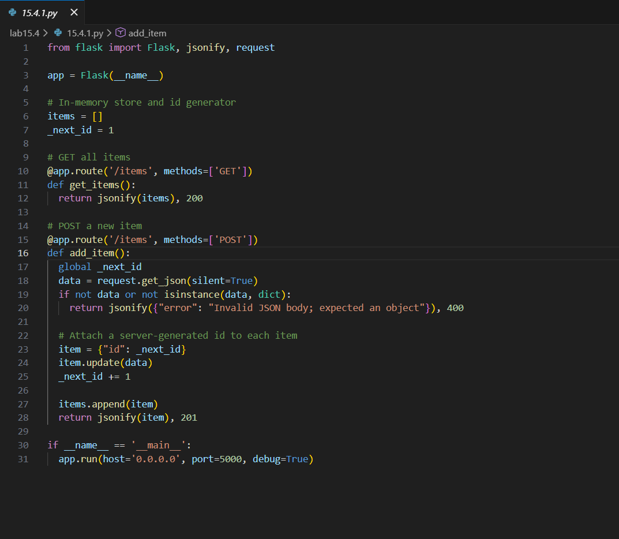
OUTPUT:
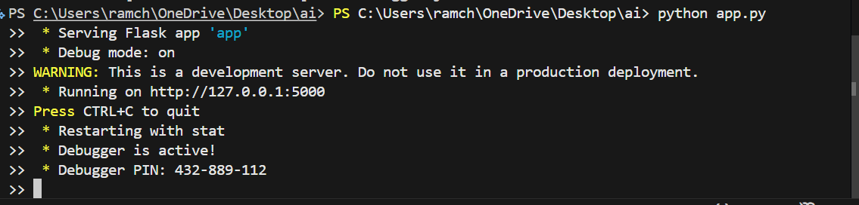
OBSERVATION
The AI made building a Flask server very easy. It generated clear code, fixed errors quickly, and helped me run the backend without confusion. It saves time and makes learning much simpler.
TASK-02:
Create a CRUD API – Read and Create
PROMPT:
Create a Flask API with two endpoints: one to list all items using a GET request, and one to add a new item using a POST request. Store the items in a Python list.
CODE:
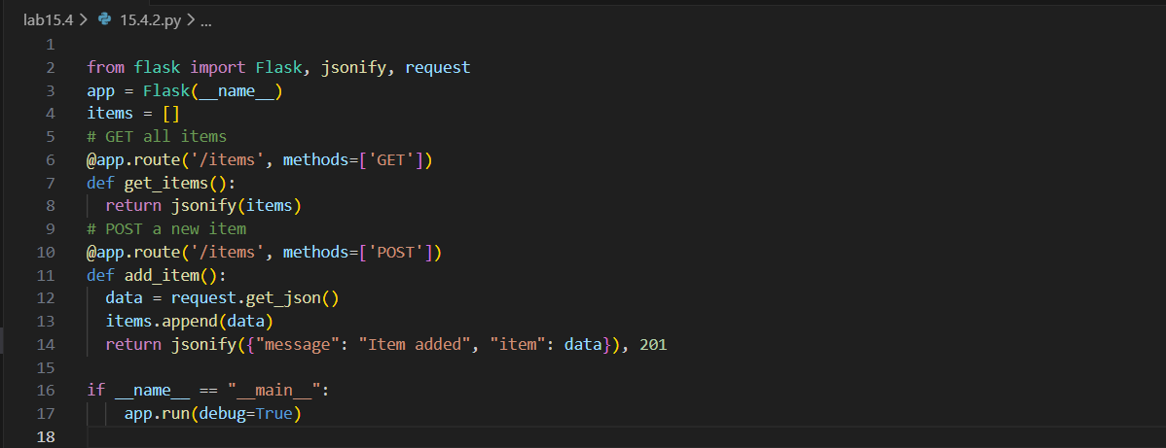

OUTPUT:
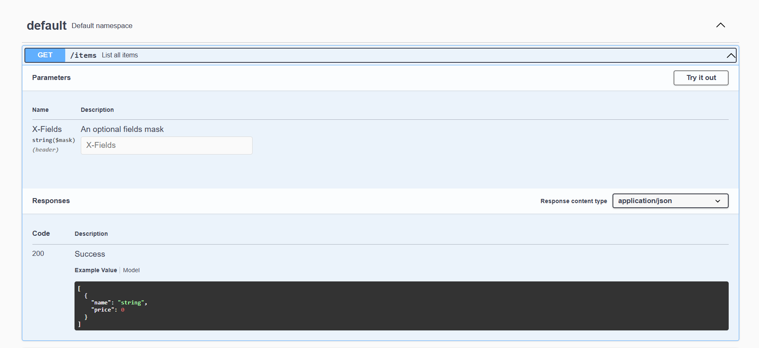
OBSERVATION:
The AI helped me build the API easily. It explained the code clearly and made the whole process faster and simpler
TASK-03:
Update Item
PROMPT:
Create a Flask PUT endpoint that updates an item in a list using its index. If the index is invalid, return an error message.
CODE:
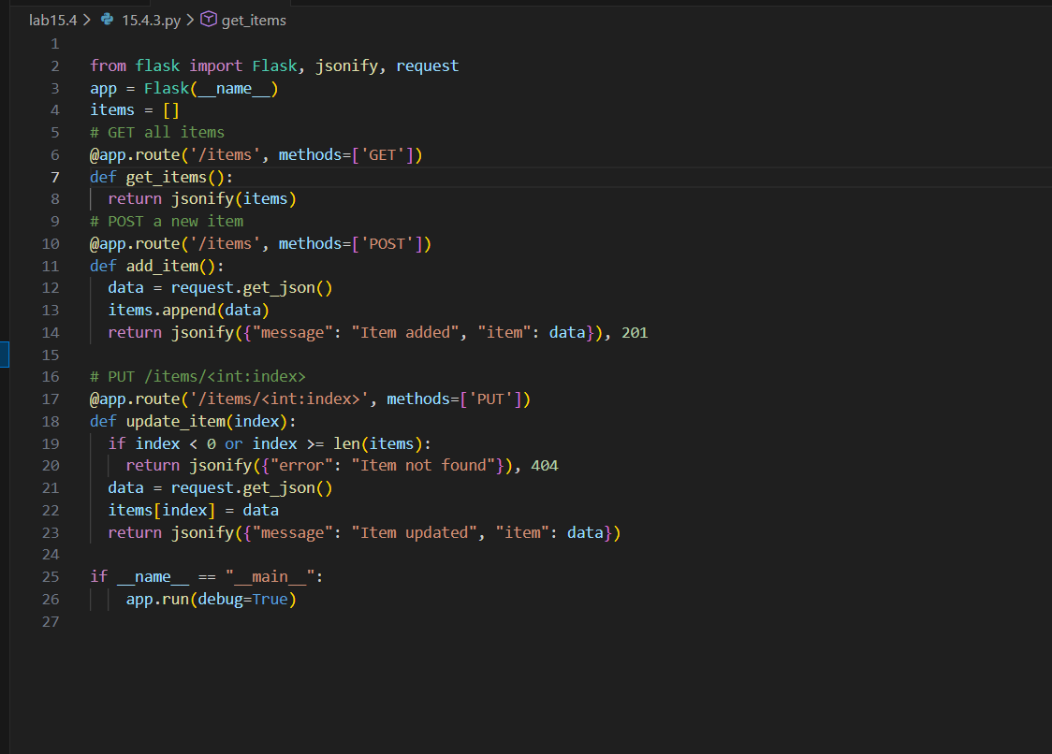
OUTPUT:
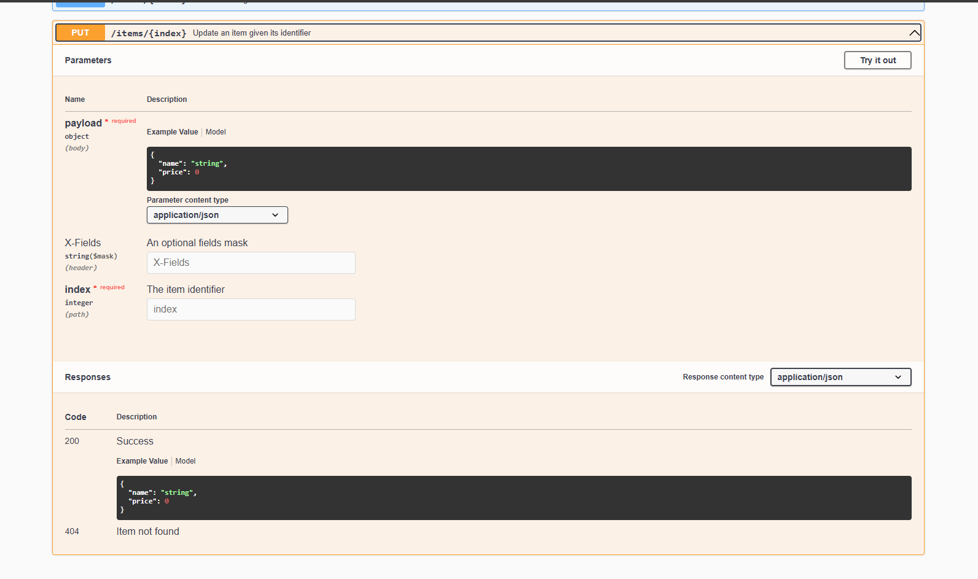
OBSERVATION:
The AI helped me easily add the update feature. It made the code simple and clear, and the task became much easier to understand.
TASK-04:
Delete Item
PROMPT:
Create a Flask DELETE endpoint that removes an item from a list using its index. If the index is invalid, return an error message.
CODE:
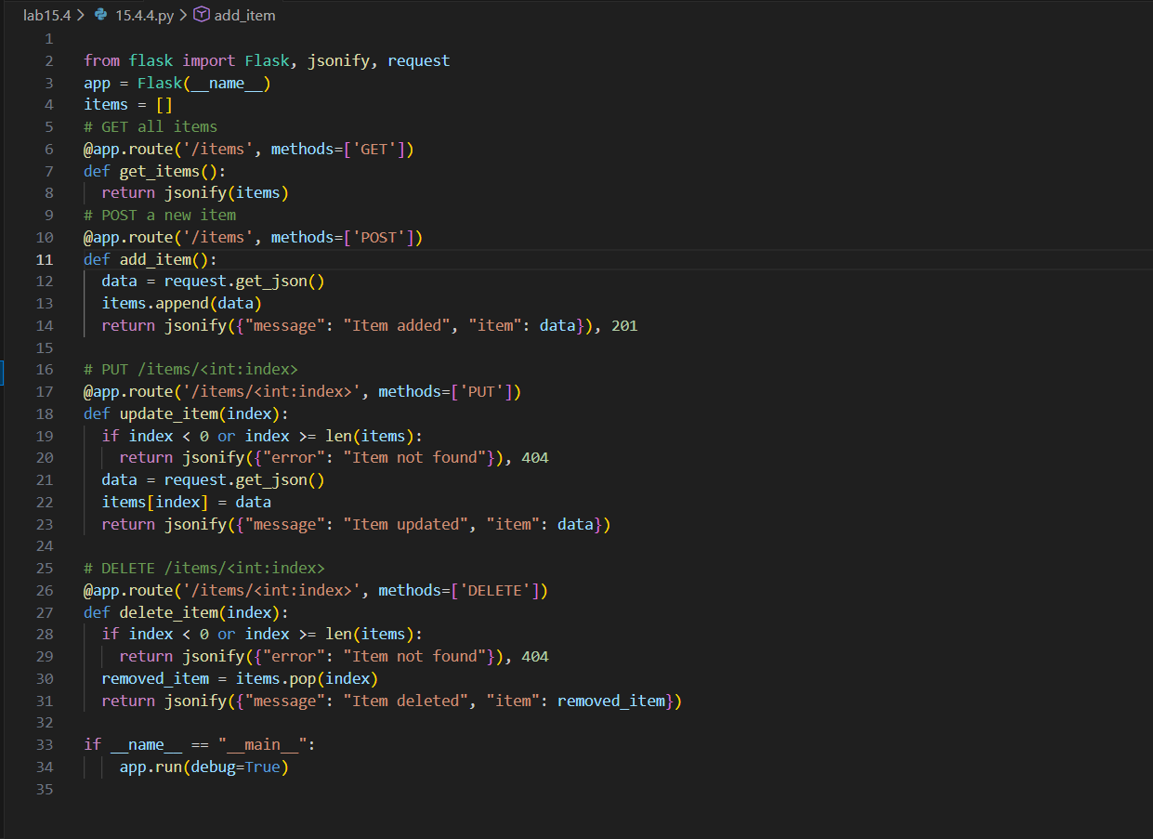
OUTPUT:
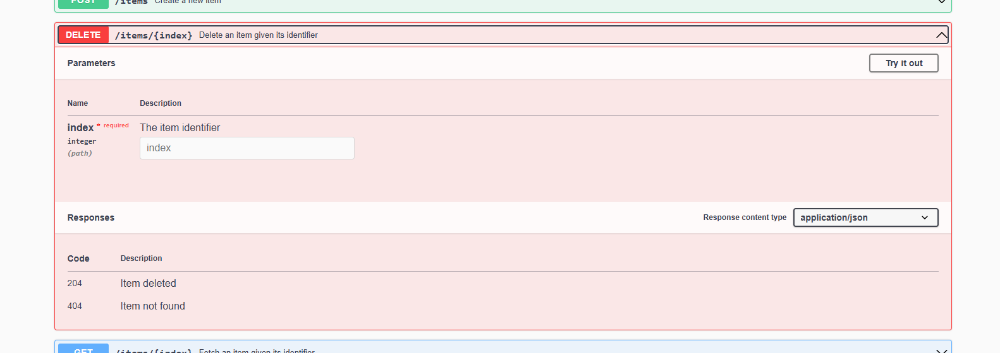
OBSERVATION:
The AI made the delete feature easy to implement. It provided clear code and helped me complete the task quickly and simply.
TASK-05:
Add Auto-Generated Documentation
PROMPT:
Add docstrings and inline comments to all Flask endpoints. Optionally use Swagger or Flask-RESTX to auto-generate API documentation so the endpoints can be viewed clearly.
CODE:
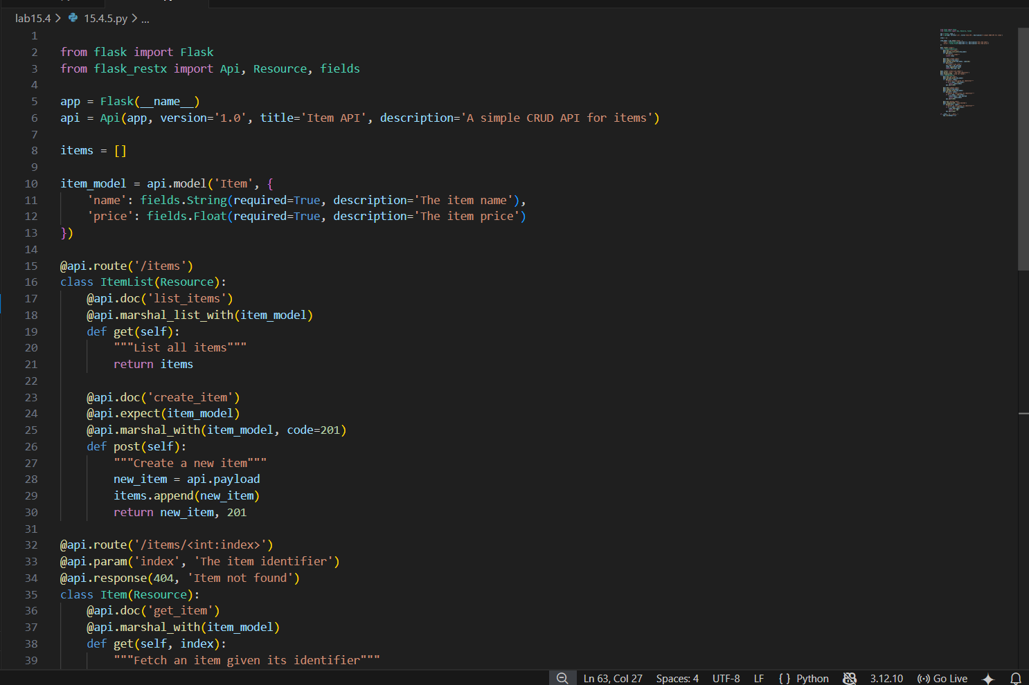
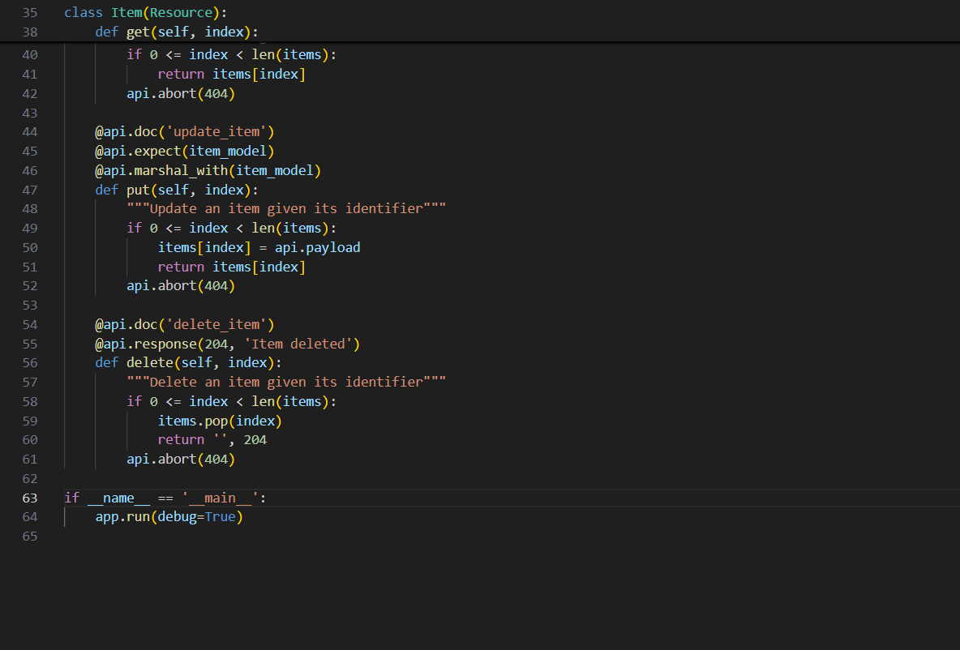

OUTPUT:
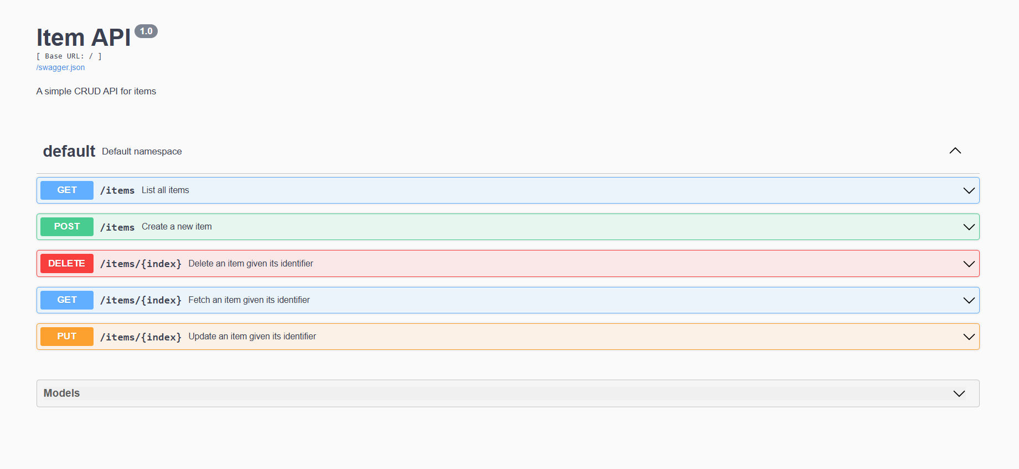
OBSERVATION:
The AI made documenting the API easy. It clearly explained each endpoint and helped create clean, readable documentation.

